Tutorial to clone weapons in game in aethra chronicles

step 1 – 3 hire a cheap hireling
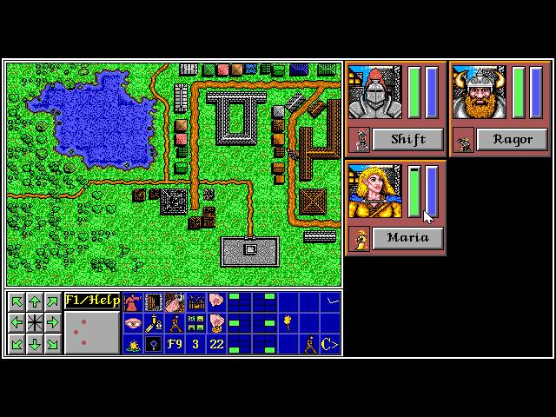

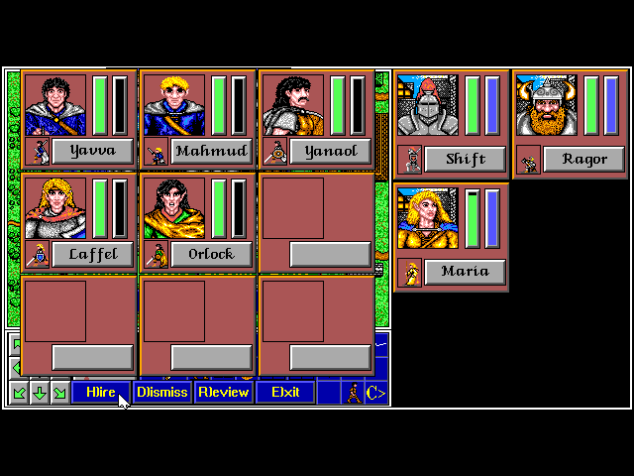
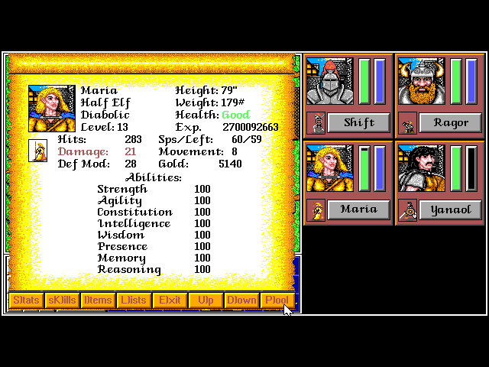
pool the gold for a party member
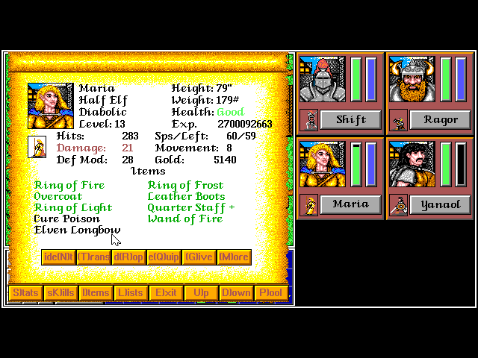
give the member the item to duplicate

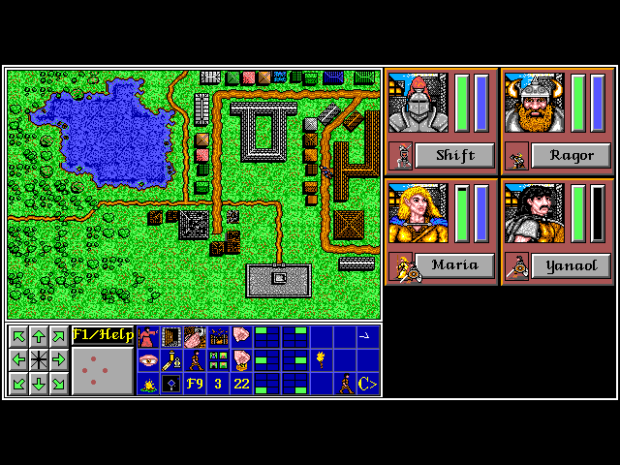
swap position from hireling and partymember

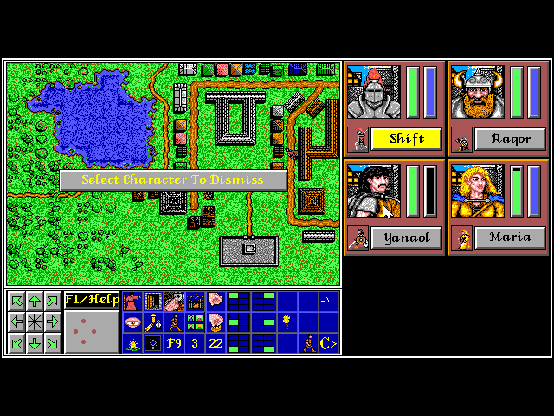
dismiss the hireling, pay or leave it

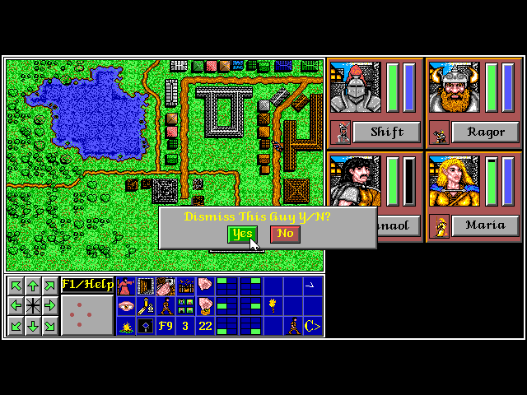
yes

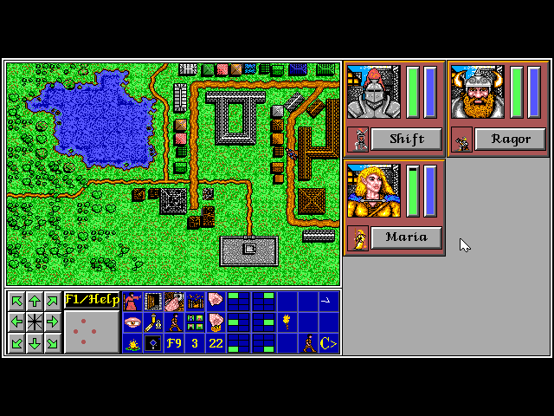
see one box less
click and drag from cursor position

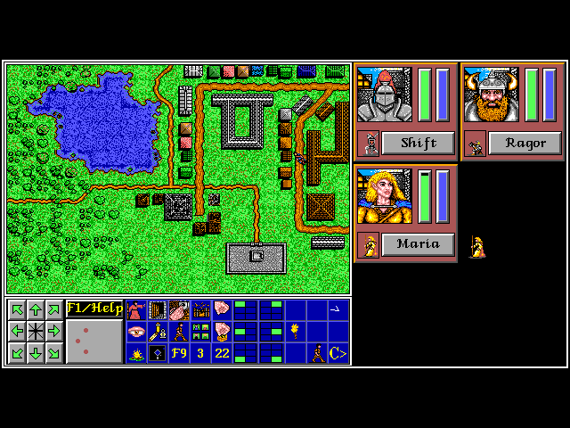
to see a partymember from out the nuthing

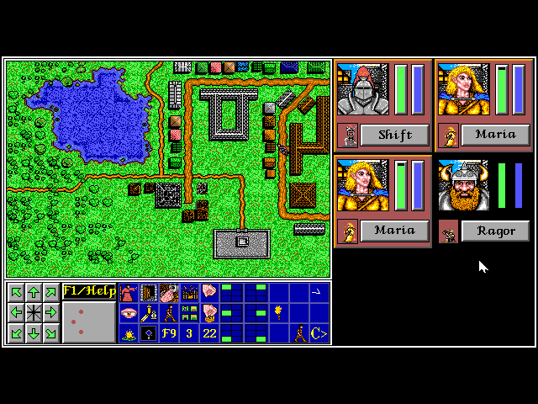
drag it to a second party member, you will get a cloned party member, with full inventory and, evt pooled gold
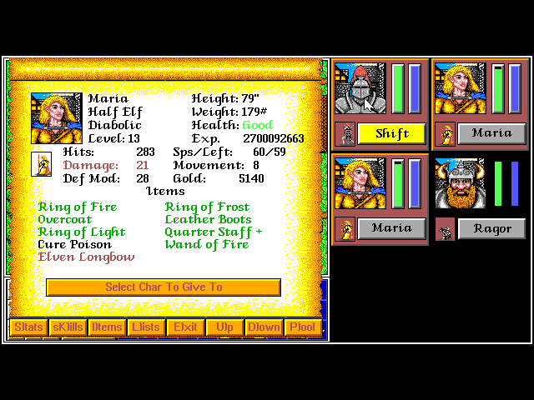
give the longbow away to another fighter

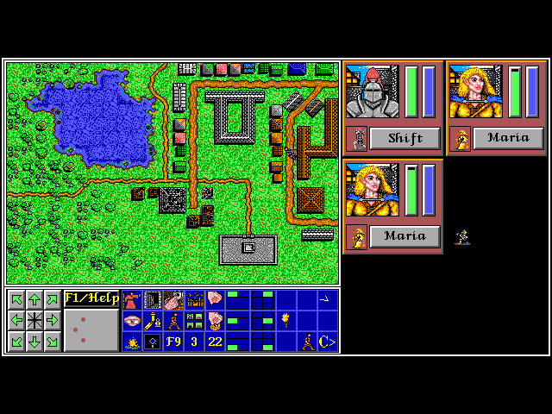
do not forget dragging the old member back on position where the duplicated member lies

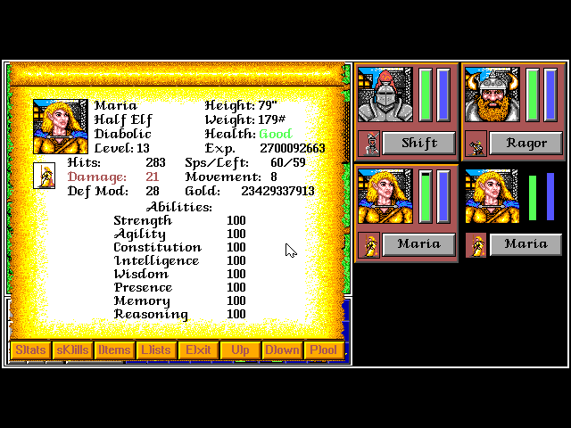
repeat this process as often as you want
this way the screen shoould look like now.

Have fun cloning one reopper items like swift killer or elvish longbow

